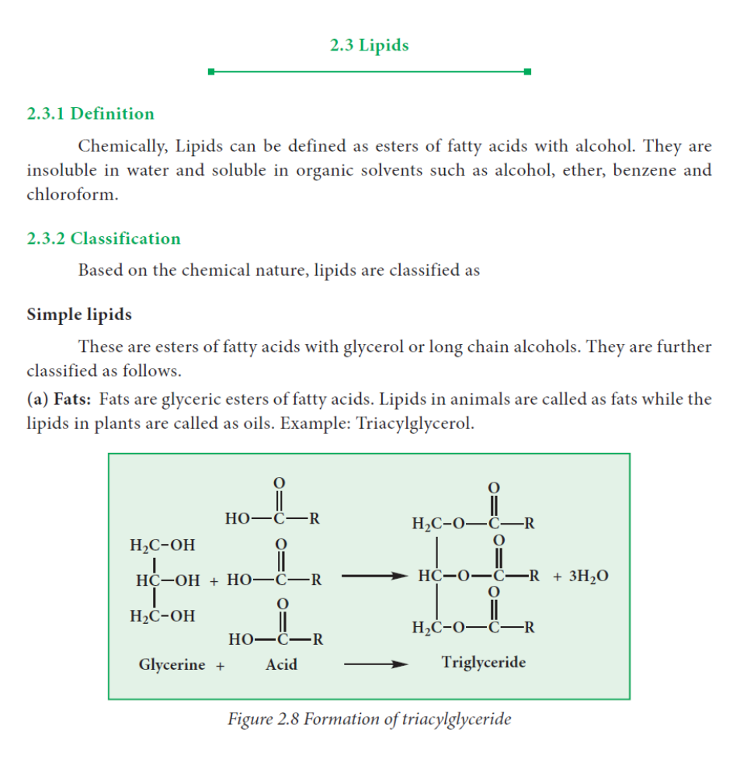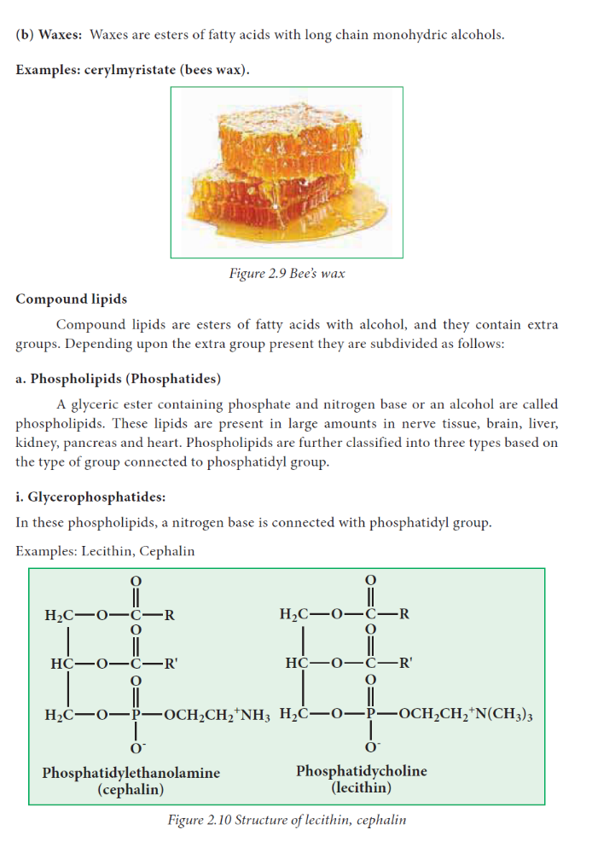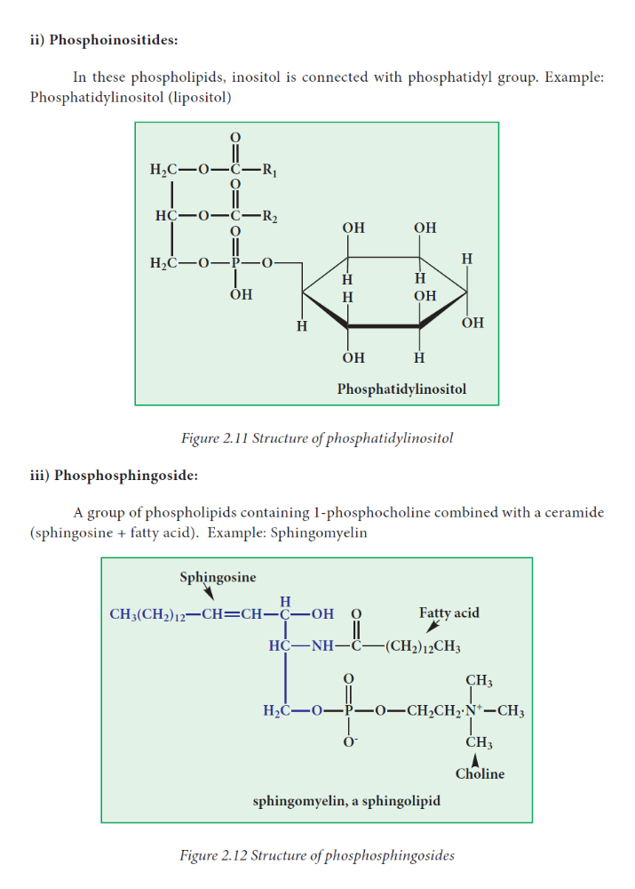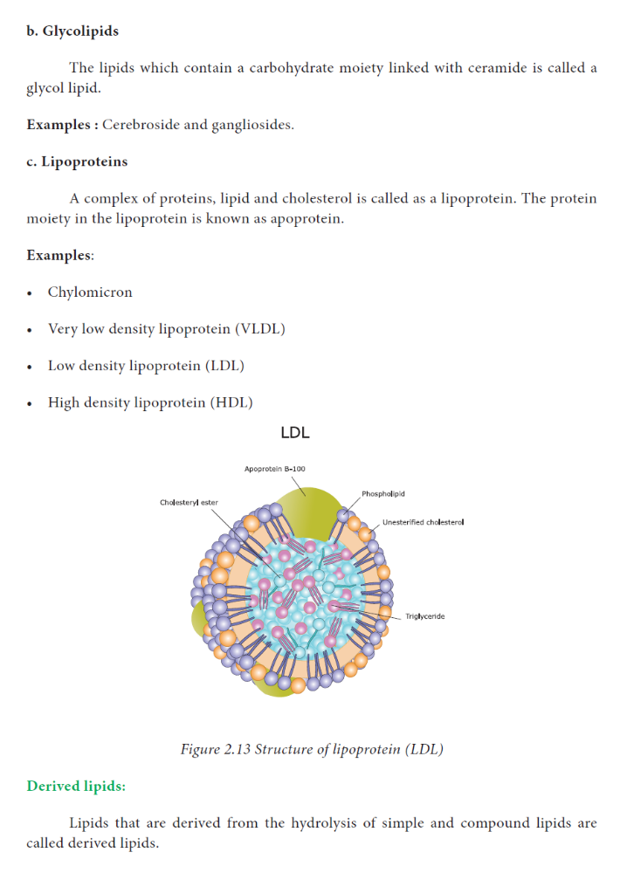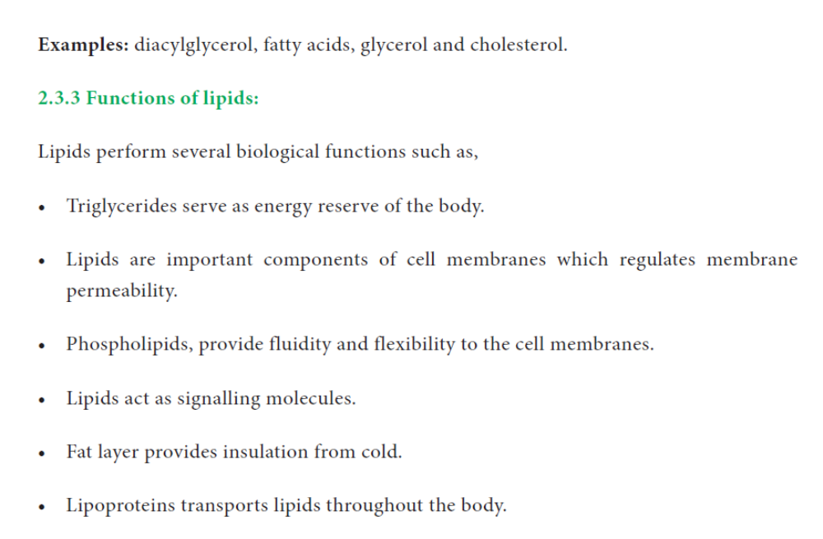

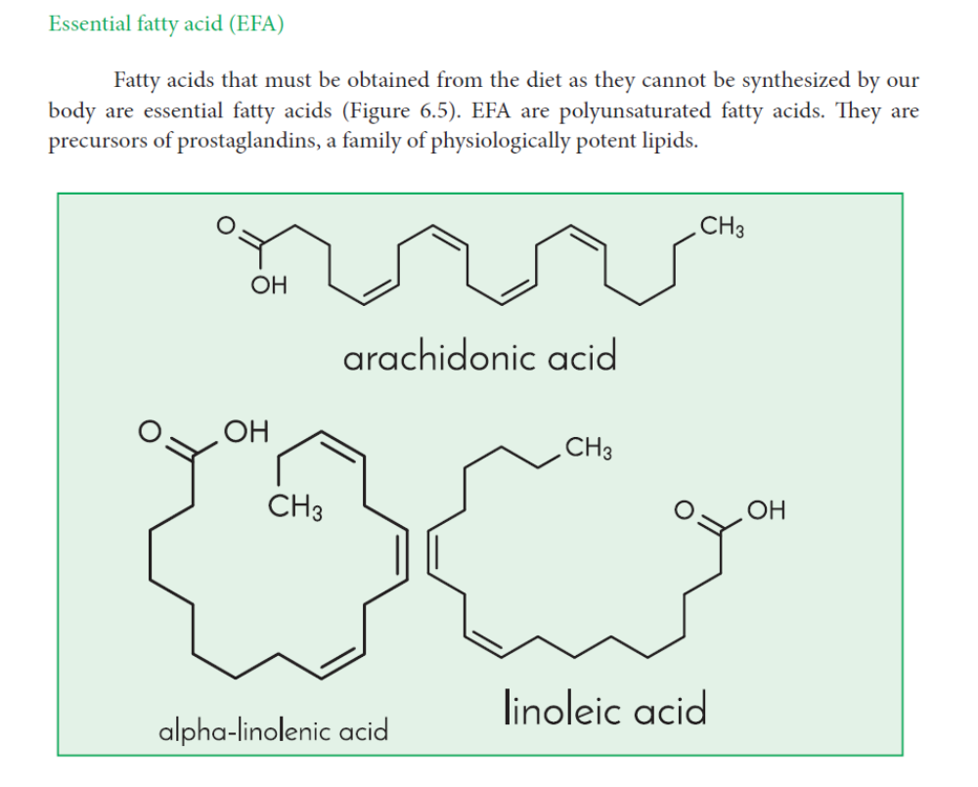

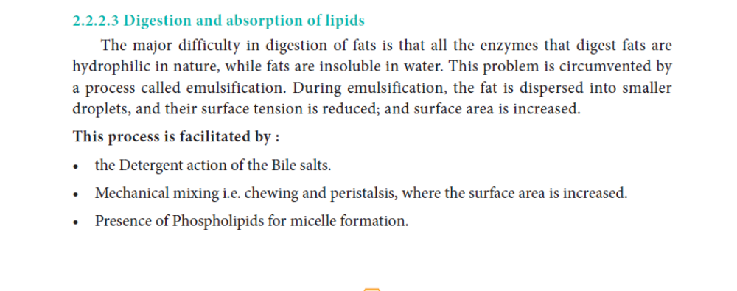

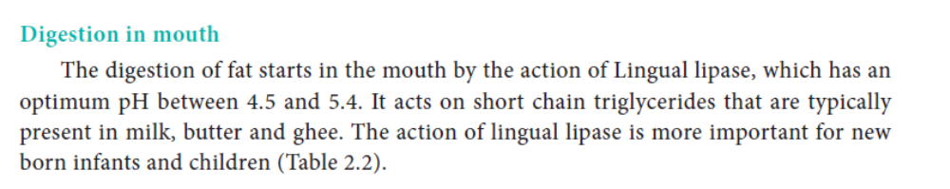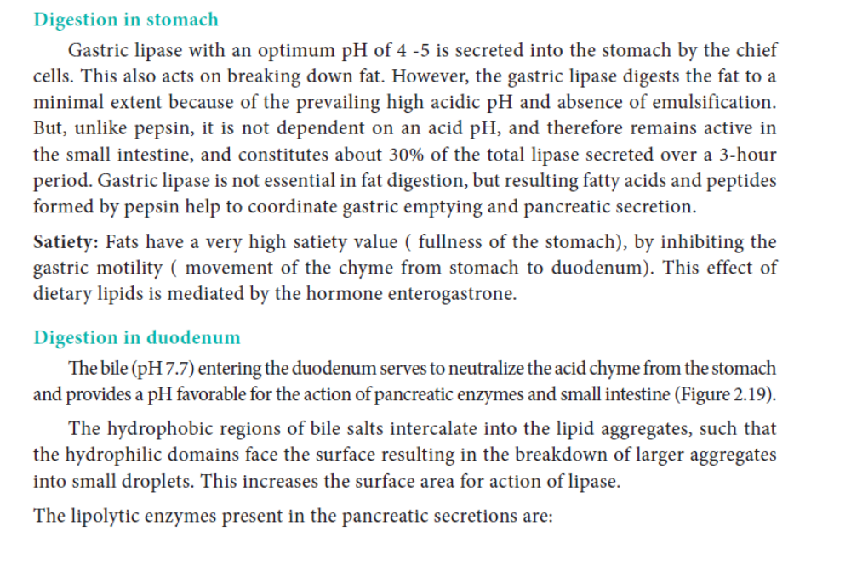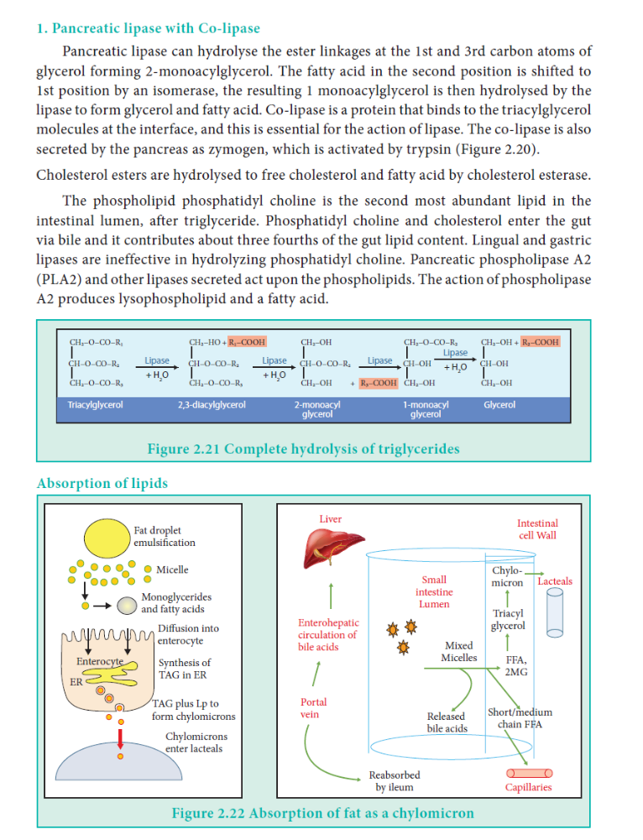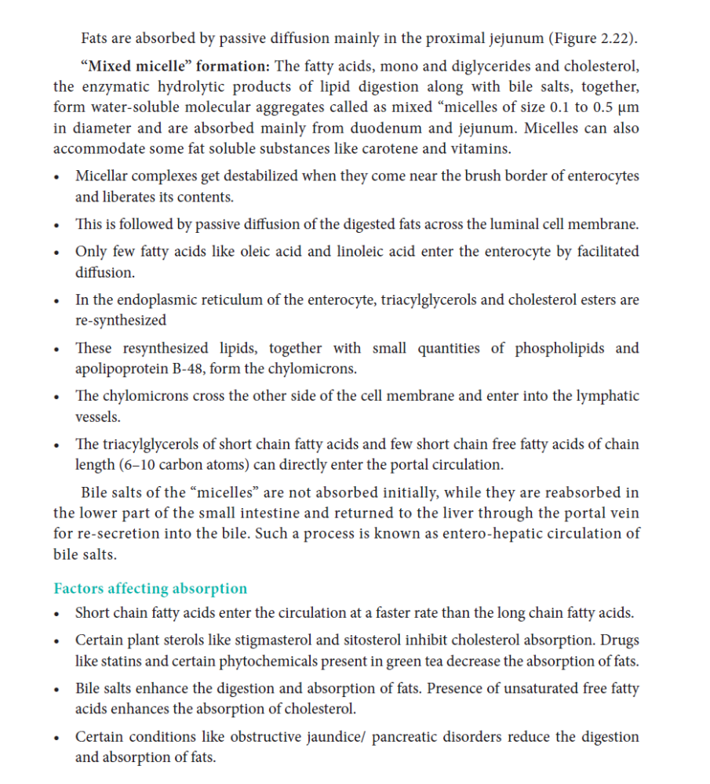
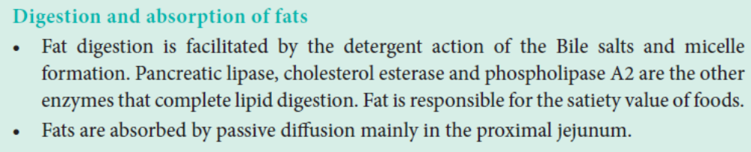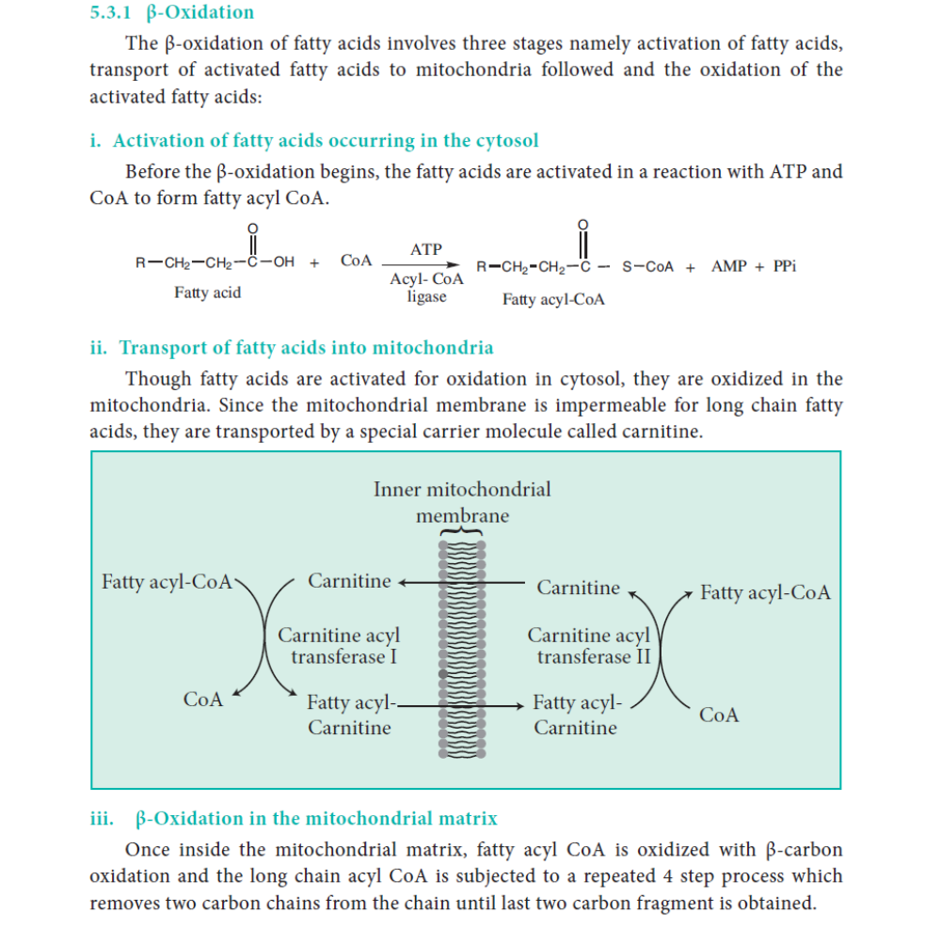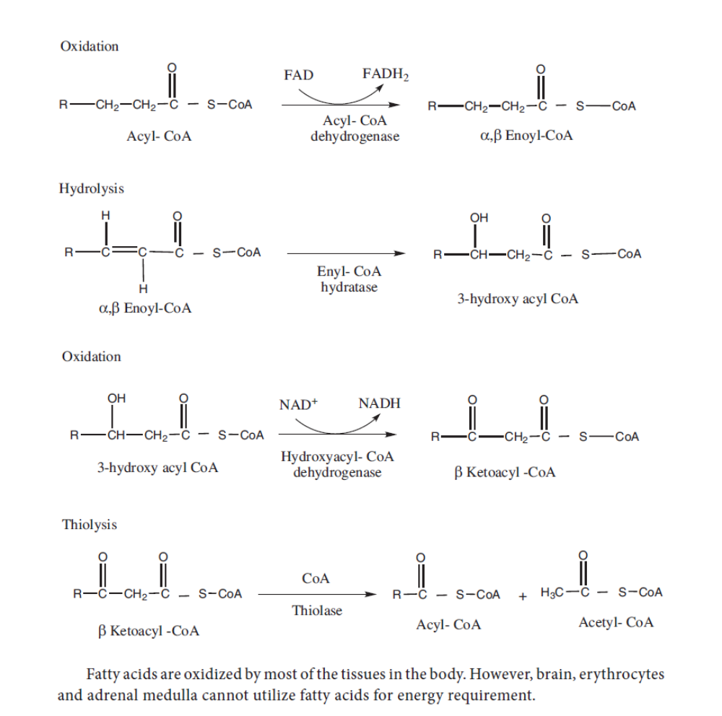

LIPID PROFILE
For total cholesterol:
- 200 milligrams per deciliter (mg/dL) or less is normal.
- 201 to 240 mg/dL is borderline.
- More than 240 mg/dL is high.
For HDL ("good cholesterol"), more is better:
- 60 mg/dL or higher is good -- it protects against heart disease.
- 40 to 59 mg/dL is OK.
- Less than 40 mg/dL is low, raising the chance of heart disease
For LDL ("bad cholesterol"), lower is better:
- Less than 100 mg/dL is ideal.
- 100 to 129 mg/dL can be good, depending on health.
- 130 to 159 mg/dL is borderline high.
- 160 to 189 mg/dL is high.
- 190 mg/dL or more is very high.
High triglycerides (150 mg/dL or greater) also raise the odds for heart disease somewhat.
Hypercholesterolaemia
Definition
Hypercholesterolaemia is defined as elevated amounts of cholesterol in the blood. Cholesterol is a waxy, fat-like substance that is naturally found in the walls of cells. It is used by the body to produce certain hormones, vitamin D, and bile acids that help to digest fat. If the amounts of cholesterol in the blood are excessive, cholesterol can build up in arteries, which can lead to coronary heart disease and many other serious conditions.
